Question 2) Simulation of Star Topology using Packet Tracer
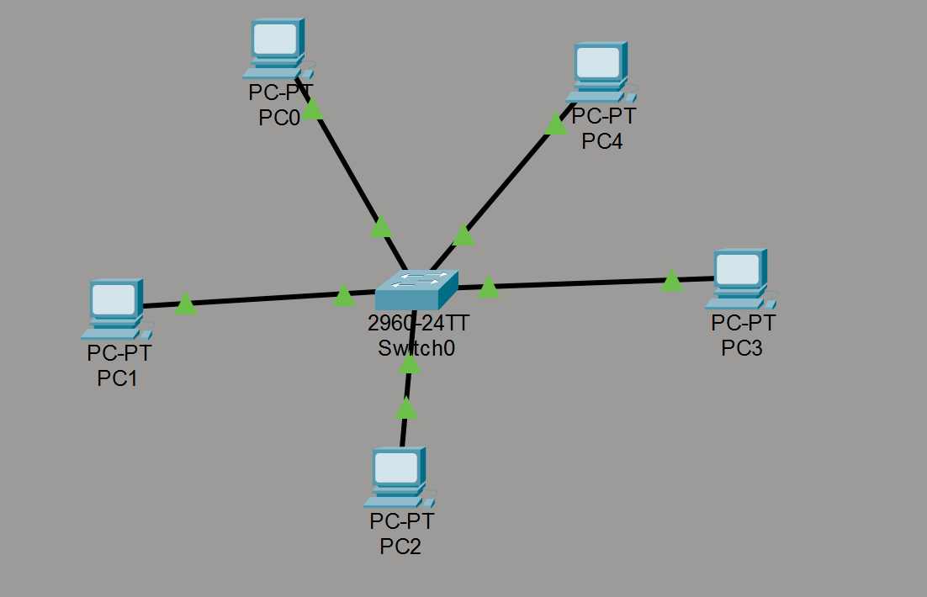

Step 1: Open Packet Tracer
- Launch Cisco Packet Tracer
- Click on Logical Workspace

Step 2: Add Devices
- From Network Devices -> Switches, drag a 2960-24TT Switch to the workspace.
- From End Devices, drag five generic PCs (PC-PT) to the workspace surrounding the switch. (These will be automatically named PC0, PC1, PC2, PC3, and PC4).

Step 3: Connect the Devices
- Click Connections.
- Select the Copper Straight-Through cable (solid black line).
- Connect PC0 (FastEthernet0) to the Switch (FastEthernet0/1).
- Repeat the process to connect all remaining PCs (PC1, PC2, PC3, PC4) to available FastEthernet ports on the central Switch using Straight-Through cables.
Step 4: Assign IP Address to PC0
- Click PC0.
- Go to Desktop inside the pc go to IP Configuration.
- Enter:
  - IP Address: 10.10.10.1
  - Subnet Mask: 255.0.0.0
- Close window.
Step 5: Assign IP Address to PC1
- Click PC1.
- Go to Desktop inside the pc go to IP Configuration.
- Enter:
  - IP Address: 10.10.10.2
  - Subnet Mask: 255.0.0.0
- Close window.

Step 6: Assign IP Address to PC2
- Click PC2.
- Go to Desktop inside the pc go to IP Configuration.
- Enter:
  - IP Address: 10.10.10.3
  - Subnet Mask: 255.0.0.0
- Close window.
Step 7: Assign IP Address to PC3
- Click PC3.
- Go to Desktop inside the pc go to IP Configuration.
- Enter:
  - IP Address: 10.10.10.4
  - Subnet Mask: 255.0.0.0
- Close window.
Step 8: Assign IP Address to PC4
- Click PC4.
- Go to Desktop inside the pc go to IP Configuration.
- Enter:
  - IP Address: 10.10.10.5
  - Subnet Mask: 255.0.0.0
- Close window.
Step 9: simulate the model and check the connectivity
use the PDU tool to send a packet from PC0 to PC3 to verify connection through the switch

